LAB TEST-01
AI ASSISTED CODING
HT.NO:2403A52415
- Write a Python code to calculate the sum of odd and even numbers in a given list using GitHub Copilot along with VS Code. Use zero shot prompting
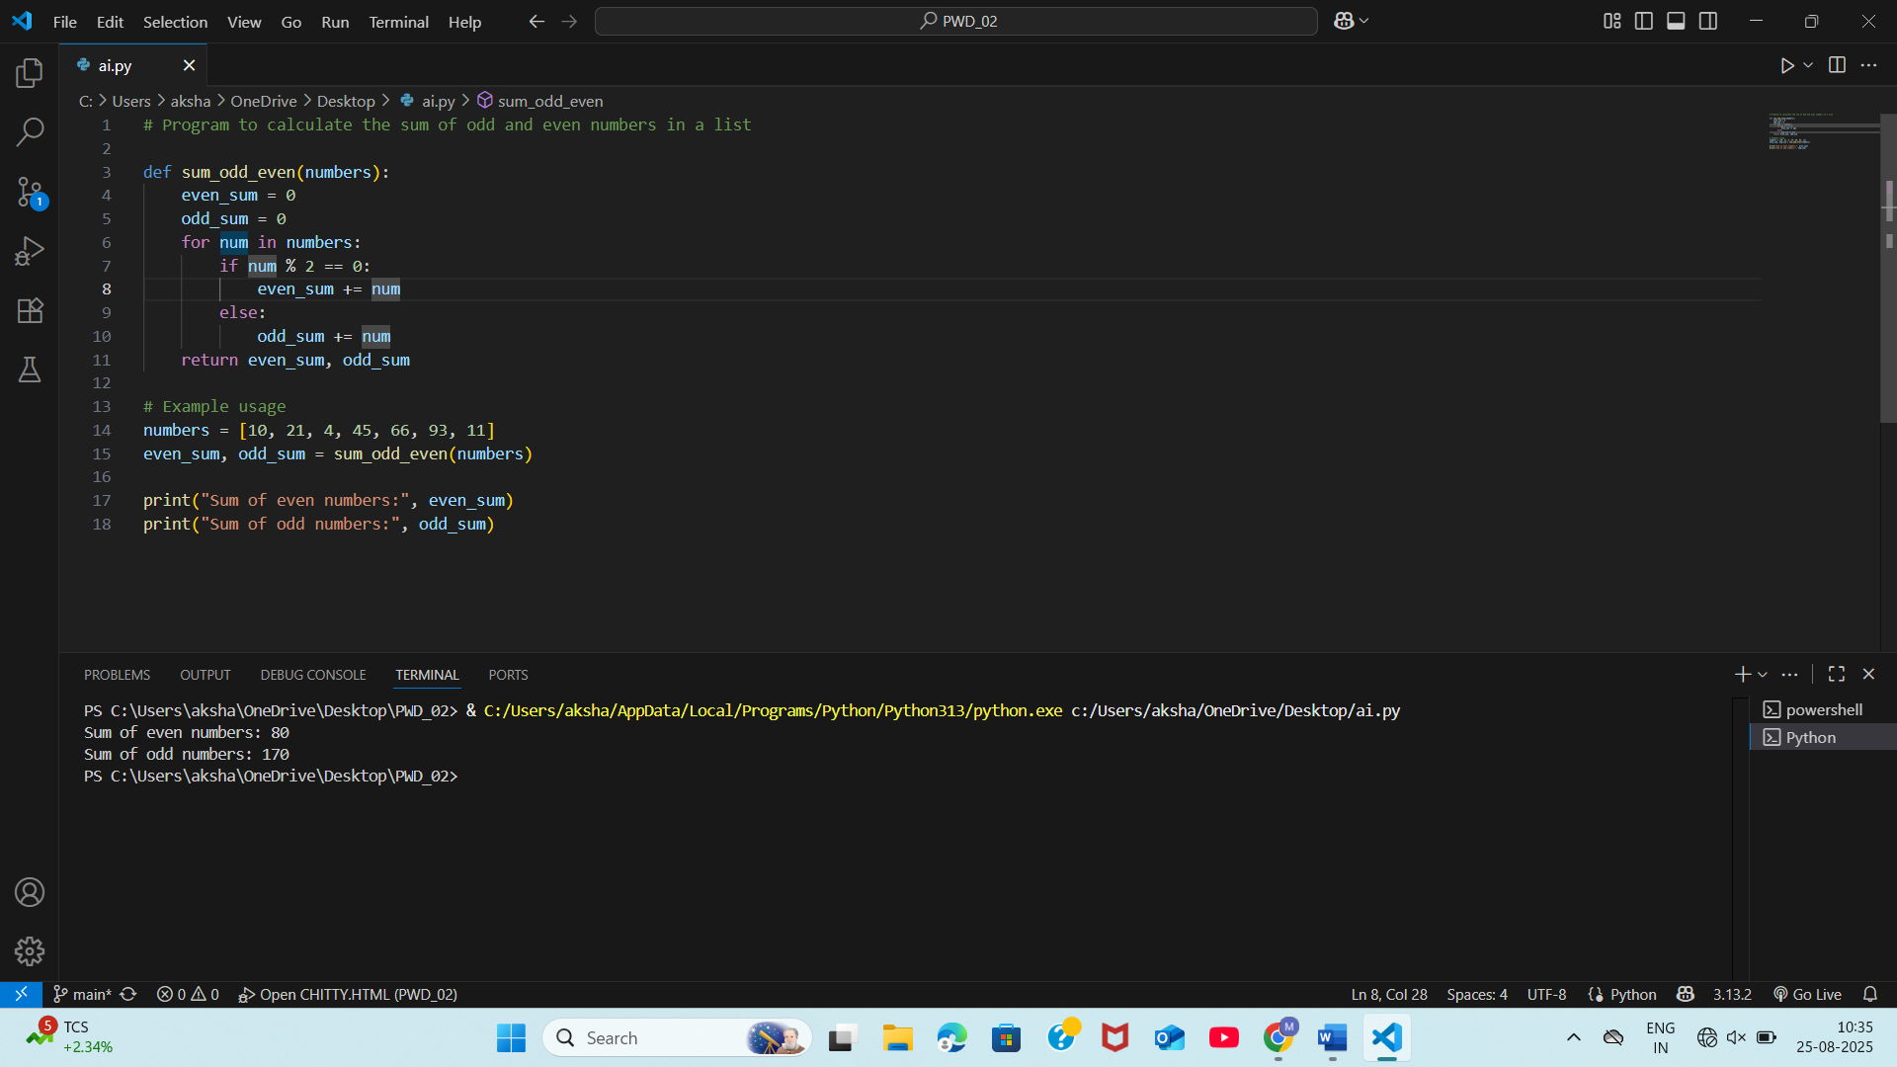
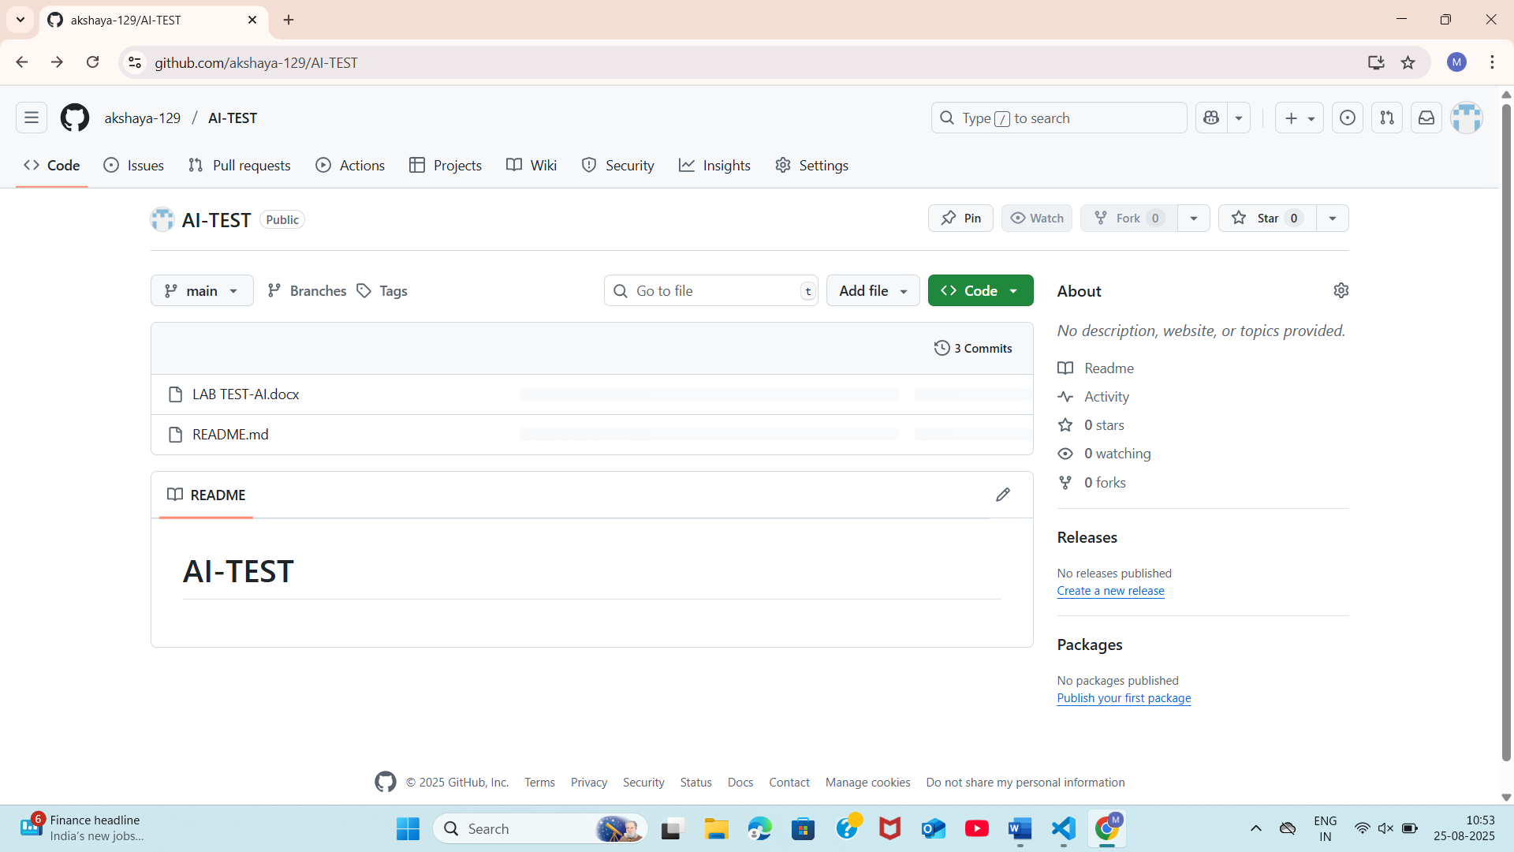
- Write a Python code for given a list of integers, remove duplicates and print the sorted result. GitHub Copilot along with VS Code. Use one shot prompting.
